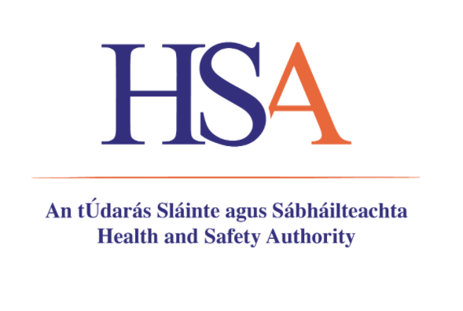

Risk Management Option Analysis Conclusion Document

Substance Name: Nitrilotriacetic acid

EC Number: 205-355-7
CAS Number: 139-13-9

Authority: Health and Safety Authority
Date: May, 2022

DISCLAIMER

The author does not accept any liability with regard to the use that may be made of the information contained in this document. Usage of the information remains under the sole responsibility of the user. Statements made or information contained in the document are without prejudice to any further regulatory work that ECHA or the Member States may initiate at a later stage. Risk Management Option Analyses and their conclusions are compiled on the basis of available information and may change in light of newly available information or further assessment.

Foreword

The purpose of Risk Management Option analysis (RMOA) is to help authorities decide whether further regulatory risk management activities are required for a substance and to identify the most appropriate instrument to address a concern.

RMOA is a voluntary step, i.e., it is not part of the processes as defined in the legislation. For authorities, documenting the RMOA allows the sharing of information and promoting early discussion, which helps lead to a common understanding on the action pursued. A Member State or ECHA (at the request of the Commission) can carry out this case-by-case analysis in order to conclude whether a substance is a 'relevant substance of very high concern (SVHC)' in the sense of the SVHC Roadmap to 2020.

An RMOA can conclude that regulatory risk management at EU level is required for a substance (e.g. harmonised classification and labelling, Candidate List inclusion, restriction, other EU legislation) or that no regulatory action is required at EU level. Any subsequent regulatory processes under the REACH Regulation include consultation of interested parties and appropriate decision making involving Member State Competent Authorities and the European Commission as defined in REACH.

This Conclusion document provides the outcome of the RMOA carried out by the author authority. In this conclusion document, the authority considers how the available information collected on the substance can be used to conclude whether regulatory risk management activities are required for a substance and which is the most appropriate instrument to address a concern. With this Conclusion document the Commission, the competent authorities of the other Member States and stakeholders are informed of the considerations of the author authority. In case the author authority proposes in this conclusion document further regulatory risk management measures, this shall not be considered initiating those other measures or processes. Since this document only reflects the views of the author authority, it does not preclude Member States or the European Commission from considering or initiating regulatory risk management measures which they deem appropriate.

OVERVIEW OF OTHER PROCESSES / EU LEGISLATION
RMOA |  | ☒ Risk Management Option Analysis (RMOA) - Ireland, May 2022
REACH Processes | Evaluation | ☐ Compliance check, Final decision
 |  | ☐ Testing proposal
 |  | ☐ CoRAP and Substance Evaluation
 | Authorisation | ☐ Candidate List
 |  | ☐ Annex XIV
 | Restri-ction | ☐ Annex XVII
Harmonised C&L |  | ☐ Annex VI (CLP) (see section 3.1)
Processes under other EU legislation |  | ☐ Plant Protection Products Regulation  Regulation (EC) No 1107/2009
☐ Biocidal Product Regulation
Regulation (EU) 528/2012 and amendments
Previous legislation |  | ☐ Dangerous substances Directive  Directive 67/548/EEC (NONS)
☒ Existing Substances Regulation
Regulation 793/93/EEC (RAR/RRS)
(UNEP) Stockholm convention (POPs Protocol) |  | ☐ Assessment
 |  | ☐ In relevant Annex
Other processes/ EU legislation |  | ☒ Other (provide further details below),

CONCLUSION OF RMOA
This conclusion is based on the REACH and CLP data as well as other available relevant information taking into account the SVHC Roadmap to 2020, where appropriate.

Conclusions | Tick box
Need for follow-up regulatory action at EU level:
Harmonised classification and labelling | X
Identification as SVHC (authorisation)
Restriction under REACH
Other EU-wide regulatory measures
Need for action other than EU regulatory action
No action needed at this time

Need for follow-up regulatory action at EU level

Harmonised classification and labelling
Nitrilotriacetic acid does not have a harmonised classification under Regulation (EC) No 1272/2008 on the classification, labelling and packaging of substances and mixtures (CLP Regulation). It is self-classified as Carcinogenicity Category 2 H351 by 352 of 514 notifiers to the C&L Inventory.
Trisodium nitrilotriacetate is the most commonly used salt of nitrilotriacetic acid. In terms of toxicology and ecotoxicology, it is expected that Na₃NTA would dissociate into NTA and Na⁺ and therefore the hazardous properties of Na₃NTA are expected to be driven by NTA. Trisodium nitrilotriacetate has a harmonised classification as Carcinogenicity Category 2 H351 under CLP.
Based on current available information including read-across justification to Trisodium Nitrilotriacetate and CLP notifications, we consider the data included in the RMOA supports the need for further risk management in the preparation of an Annex VI CLH dossier for harmonised classification for Carcinogenicity Category 2.
Since Nitrilotriacetic acid has industrial, professional and consumer uses, and since not all notifiers to the C&L database have self-classified as Carc. 2, we conclude that the most appropriate risk management measure is to prepare an Annex VI CLH dossier for harmonised classification.

TENTATIVE PLAN FOR FOLLOW-UP ACTIONS IF NECESSARY
Indication of a tentative plan is not a formal commitment by the authority. A commitment to prepare a REACH Annex XV dossier (SVHC, restrictions) and/or CLP Annex VI dossier should be made via the Registry of Intentions.
Follow-up action | Date for follow-up | Actor
Proposed Annex VI CLH dossier for Nitrilotriacetic Acid for harmonised classification | 2023-2024 | CA Ireland

For more information on the SVHC Roadmap: http://echa.europa.eu/addressing-chemicals-of-concern/substances-of-potential-concern/svhc-roadmap-to-2020-implementation
Compliance check opened and closed (2016) without issuing a compliance check final decision
European Union Risk Assessment Report Trisodium Nitrilotriacetate
Detergent Regulations (EC) No. 648/2004
COMMISSION DECISION (EU) 2017/1218 of 23 June 2017 establishing the EU Ecolabel criteria for laundry detergents

